YPGym Web Application
Integrated Business Requirements Document and Project Brief

Document Item | Details
Project Name | YPGym Membership and Gym Management System
Project Type | Full-stack web application + mobile app
Frontend | React, Vite, TypeScript, Tailwind CSS, shadcn/ui
Backend | Python FastAPI, PostgreSQL, SQLAlchemy, Alembic
Target Users | Gym members (VIP, Advance, normal), administrators, personal trainers, staff, manager
Purpose | Digitalize membership, attendance, class registration, billing, CRM, notifications, and controlled AI support

** Draw Use case diagram**
**Implement IOT**
** Implement error handling**

1. Project Overview
YPGym is a full-stack web application designed to digitalize gym membership management, attendance tracking, class registration, billing, customer relationship management and controlled AI-assisted support. The system replaces manual spreadsheet-based operations with a centralized platform for members, administrators and personal trainers.
The application allows members to register, verify their account, sign in, purchase or renew memberships, receive invoices, use rotating QR codes for attendance, book classes, manage notifications and query approved system information through an AI chatbot. Administrators can manage customer data, membership status, class schedules, personal trainer assignments, billing records, cancellation workflows, revocations, attendance analytics, audit logs and broadcast announcements.

2. Business Problem
YPGym currently relies on manual processes such as spreadsheets and staff-managed records for memberships, payments, attendance, customer status and class bookings. This creates risks of duplicated records, incorrect expiry dates, missed renewals, unclear attendance data and increased workload for staff.
Members also lack a convenient self-service experience. Without an online platform, they cannot easily renew memberships, check crowdedness, book classes, manage personal details, view invoices or receive automated expiry reminders. A centralized web system is required to improve accuracy, reduce administrative effort and improve the member experience.

3. Project Objectives
- Create a centralized digital platform for membership, attendance, class booking, billing and CRM operations.
- Allow members to self-register, verify accounts, manage profiles, purchase or renew plans and receive invoices.
- Use rotating QR codes to support secure attendance tracking and real-time occupancy data.
- Provide an admin CRM dashboard for member, class, PT, billing, cancellation and audit management.
- Provide controlled AI chatbot support for system-related queries using authenticated backend context.
- Support a scalable architecture suitable for 1000+ registered users.

4. Proposed Solution
The proposed solution is a responsive web application using React for the frontend and Python FastAPI for the backend. The system will be modular, separating authentication, membership, attendance, class booking, billing, notifications, administration and chatbot functions.
Members will access a mobile-friendly dashboard for membership status, QR check-in, class registration, invoices, notifications and chatbot support. Admins will access a CRM dashboard for member management, membership lifecycle management, payments, billing history, attendance trends, crowdedness, class schedules, PT assignments, broadcast announcements and audit logs.

5. Recommended Technology Stack

5.1 Frontend Stack
The recommended frontend stack is React with Vite and TypeScript, supported by Tailwind CSS and shadcn/ui for a sleek, minimal and responsive interface. This combination is suitable for a modern gym platform because it supports clean dashboards, forms, tables, cards, modals and mobile-first layouts without looking overly generic.
Area | Recommended Tool | Purpose
Framework | React + Vite | Fast frontend development and reusable UI components
Language | TypeScript | Improves maintainability and reduces runtime errors
Styling | Tailwind CSS | Responsive utility-first styling
UI Library | shadcn/ui | Minimal dashboard-quality components
Routing | React Router | Public, member and admin page navigation
Forms | React Hook Form + Zod | Form handling and validation
API State | ??? | Server-state caching and API request management
Tables | ???? | Admin CRM filtering, sorting and CSV export support
Charts | Recharts | Crowdedness, revenue and peak-hours heatmap charts
QR Display | qrcode.react | Display rotating QR code to members
Notifications | Sonner or React Toastify | Success, warning and error messages
Mobile Experience | Expo, PWA | Mobile-friendly experience without needing native app development initially

5.2 Backend Stack
The recommended backend framework is FastAPI because the project is API-heavy and requires authentication, role-based access, membership logic, QR attendance, class booking, billing, notifications and chatbot endpoints. FastAPI also provides automatic API documentation, strong typing through Pydantic and high-performance async support.
Area | Recommended Tool | Purpose
Framework | FastAPI | Scalable Python API backend
Database | PostgreSQL | Reliable relational database for members, payments, attendance and classes
ORM | SQLAlchemy | Database modelling and query management
Migration | Alembic | Version-controlled database schema changes
Validation | Pydantic | Request and response validation
Authentication | JWT + role-based access control | Secure member/admin/PT access
Password Security | bcrypt / passlib | Secure password hashing
Caching | Redis | Fast crowdedness and session/token caching
Background Jobs | Celery + Redis or APScheduler | Expiry reminders, invoice processing and scheduled tasks
QR Generation | qrcode / signed token library | Secure rotating QR generation
Invoice PDF Generation | ReportLab or WeasyPrint | PDF invoice generation
AI Integration | OpenAI API or LangChain with backend guardrails | Controlled chatbot functionality
Deployment | Docker + Uvicorn/Gunicorn | Scalable deployment with worker processes

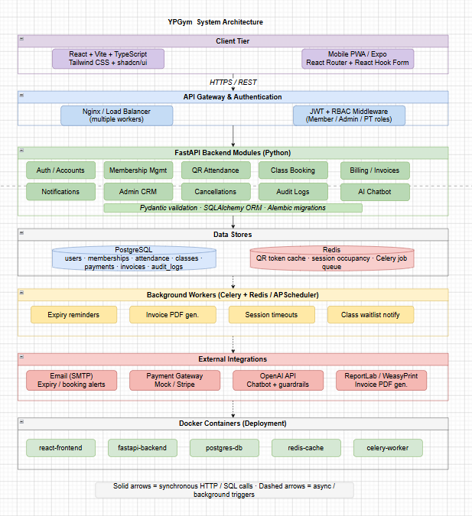
Figure 1 YPGym system architecture diagram

5.3 Scalability Consideration for 1000+ Users ( Next phase)
FastAPI with PostgreSQL is suitable for 1000+ registered users when deployed with proper worker processes, indexed database fields, caching and background task separation. Since not all registered users will be active at the same time, the highest traffic areas are likely to be login, QR attendance, membership queries, class booking and crowdedness display.
- Use PostgreSQL rather than SQLite for production-like reliability.
- Index common query fields such as user_id, email, phone, membership_status, expiry_date, class_id and attendance_session_id.
- Use Redis for temporary QR token validation and current occupancy data.
- Use background jobs for email reminders and invoice generation rather than blocking user requests.
- Deploy using multiple Uvicorn/Gunicorn workers inside Docker when moving beyond local development.

6. User Roles
Role | Description
Member | Registers, verifies account, logs in, purchases or renews memberships, uses rotating QR code, books classes, manages profile and notifications, views invoices and uses approved chatbot support.
Admin | Manages CRM records, memberships, billing, attendance, classes, PT assignments, cancellation approvals, revocations, audit logs, CSV exports and broadcast announcements.
Personal Trainer | Appears in PT profile cards and class assignments. PT schedule management may be limited in MVP unless expanded into a separate PT dashboard.
** Devide component into many Dockers**

7. Functional Requirements
This section is the single source of truth for functional requirement identifiers. No duplicate FR addendum is used. Any future changes should update this table directly or be documented in a separate changelog without reusing FR IDs.
ID | Requirement | Description | Platform | Priority
FR1 | User registration | Users shall be able to create an account using required personal details, email/phone and password. | Web + Mobile | High
FR2 | Email verification | The system shall send a verification email after registration and require verification before full account access. | Web + Mobile | High
FR3 | User login/logout | Users shall be able to securely sign in and sign out using validated credentials. | Web + Mobile | High
FR4 | Forgot password and reset | Users shall be able to request an email-based reset link or code and set a new password after token validation. | Web + Mobile | High
FR5 | Profile self-update | Members shall be able to update allowed profile details such as name, phone, email and password with secure validation. | Web + Mobile | High
FR6 | Role-based access control | The system shall separate access between member, admin and PT-related functions. | Web + Mobile | High
FR7 | Membership plan display | Users shall be able to view available membership packages and prices. | Web + Mobile | High
FR8 | Membership purchase | Members shall be able to purchase a membership plan. | Web + Mobile | High
FR9 | Volume discount calculation | The system shall apply longer-plan discount logic for 3-month, 6-month, 1-year, 2-year and 3-year plans. | Web + Mobile | Medium
FR10 | Membership renewal/extension | Members shall be able to extend an existing membership before or after expiry. | Web + Mobile | High
FR11 | Membership expiry tracking | The system shall calculate and store membership start date, expiry date and current status. | Web + Mobile | High
FR12 | Membership freeze/hold | Eligible members shall be able to request or receive a temporary membership freeze according to business rules. | Web + Mobile | Medium
FR13 | Membership cancellation request | Members shall be able to request membership cancellation. | Web + Mobile | Medium
FR14 | Cancellation approval workflow | Admins shall verify cancellation requests and apply the defined refund, credit or forfeit rule. | Web | High
FR15 | Membership revocation | Admins shall be able to revoke member access when required, with audit trail capture. | Web | Medium
FR16 | Payment processing or mock payment | The system shall support payment capture or a simulated payment flow for membership purchase. |  | High
FR17 | Invoice generation | The system shall generate an invoice after successful membership registration or renewal. |  | High
FR18 | Payment history | Members and admins shall be able to view relevant transaction history. |  | Medium
FR19 | Billing history | Admins shall be able to view billing records and invoices for each customer. |  | Medium
FR20 | Rotating time-limited QR code | The system shall generate secure QR tokens that expire and rotate to reduce screenshot sharing risk. |  | High
FR21 | QR attendance check-in | Members shall be able to check in at the gym by presenting their valid QR code. |  | High
FR22 | QR check-out or session timeout | The system shall reduce active occupancy through exit scan/check-out or automatic session timeout. |  | High
FR23 | Duplicate check-in prevention | The system shall prevent repeated check-ins within a defined short time window. |  | High
FR24 | Gym crowdedness calculation | The system shall calculate current crowdedness using active attendance sessions. |  | High
FR25 | Capacity-based crowdedness thresholds | Crowdedness levels shall be based on percentage of configured gym capacity rather than arbitrary absolute numbers. |  | High
FR26 | Peak hours heatmap | Admins shall be able to view a day-by-hour attendance heatmap generated from attendance logs. |  | Medium
FR27 | Class listing | Members shall be able to view available classes with time, capacity and assigned trainer information. |  | High
 | Class
FR28 | Class registration | Members shall be able to register for available classes. |  | High
FR29 | Class cancellation | Members shall be able to cancel bookings within the allowed cancellation window. |  | Medium
FR30 | Class waitlist | Members shall be able to join a waitlist when a class is full and receive notification if a slot opens. |  | Medium
FR31 | PT assignment | Admins shall be able to assign personal trainers to classes. |  | Medium
 | Staff Training
FR32 | PT profile card | Members shall be able to view basic PT information when browsing classes. |  | Medium
FR33 | Admin CRM member management | Admins shall be able to search, filter and manage member profiles and status. |  | High
FR34 | Admin CSV export | Admins shall be able to export member lists and billing tables as CSV files. |  | Medium
FR35 | Audit log | The system shall record sensitive admin actions such as cancellation approval, revocation and account changes. |  | High
FR36 | Membership expiry notification | The system shall notify members before their membership expires. |  | High
FR37 | Notification preferences | Members shall be able to choose supported notification preferences such as email and in-app alerts. |  | Medium
FR38 | Admin broadcast announcement | Admins shall be able to send gym-wide announcements such as closures or class schedule changes. |  | Medium
FR39 | AI chatbot with authenticated context and guardrails | The chatbot shall answer system-related queries using injected backend context and redirect out-of-scope questions such as exercise, diet or medical advice. |  | High

8. Core Functional Scope
YPGym Use case diagram:
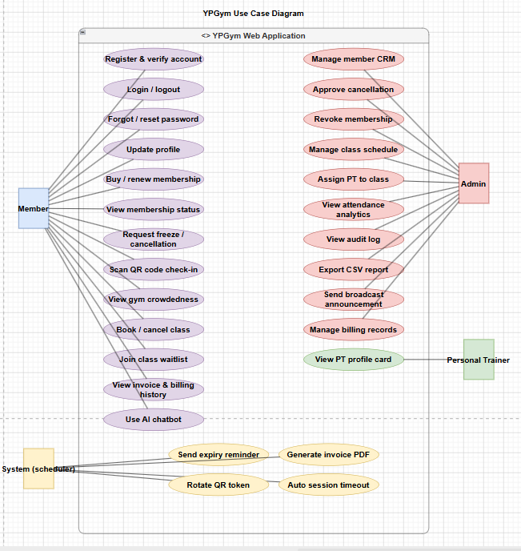
Figure 2 YPGym Use case diagram

8.1 Account and Authentication Management
The account module supports registration, email verification, login, logout, forgot password, password reset, profile self-update and secure validation for sensitive changes. Email changes should require verification before becoming active, while password changes should require the current password or a valid reset token.

8.2 Membership Management and Status Lifecycle
Memberships can be purchased for 1 month, 3 months, 6 months, 1 year, 2 years or 3 years. Longer durations should receive volume discounts. The system must track membership lifecycle status clearly because attendance, class booking and chatbot responses depend on current membership state.
Status | Meaning
Active | Member has valid gym access.
Expiring Soon | Membership is close to expiry and should trigger reminders.
Expired | Membership has passed its expiry date and access is inactive.
Cancelled | Membership has been cancelled after approved business workflow.
Revoked | Admin has manually removed access due to policy or business reasons.
Pending Verification | Cancellation, payment, profile change or account action requires verification.
Frozen | Membership is temporarily paused and expiry/access rules follow the freeze policy.
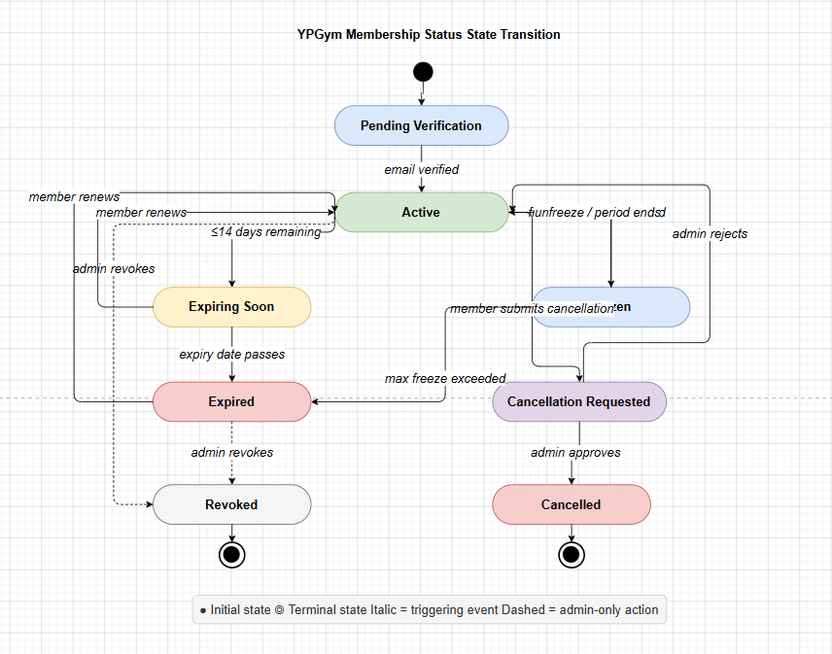
Figure 3 State Transaction diagram
Cancellation must define what happens to remaining membership value. The recommended business rule is to configure one of three outcomes: partial refund, account credit for future membership, or forfeit/no refund depending on gym policy. The selected outcome must be visible to admin before approval and stored in the audit log.

8.3 QR Attendance and Crowdedness
Members should receive a rotating time-limited QR token rather than a permanent static QR image. This reduces the risk of members screenshotting and sharing their gym access with non-members. The backend should validate the token, user identity, membership status and token expiry before recording attendance.
Crowdedness must be calculated from active attendance sessions. To prevent the occupancy count from only increasing, the system must support either an exit QR scan/check-out event or an automatic session timeout such as two hours. The preferred MVP approach is to implement automatic timeout first and optionally add exit scanning later.
Crowdedness Level | Capacity-Based Rule
Low | 0% to 30% of configured gym capacity
Moderate | 31% to 60% of configured gym capacity
Busy | 61% to 85% of configured gym capacity
Very Crowded | 86% to 100%+ of configured gym capacity

8.4 Class Registration and Personal Trainers
Members can view classes, see class capacity, view assigned PT profile cards and register for available classes. If a class is full, members may join a waitlist. If another member cancels within the permitted rules, the next waitlisted member can be automatically enrolled or notified to confirm the slot.
A booking cancellation window should be defined, such as allowing cancellation up to two hours before the class begins. This prevents late cancellations from disrupting trainer scheduling and class capacity planning.
The PT role should remain intentionally lightweight for MVP unless a full PT dashboard is added. At minimum, the member-facing class page should show a PT profile card with name, specialty and assigned class information.

8.5 Payment, Invoice and Billing
After a successful payment or simulated payment, the system activates the membership, generates an invoice, stores billing history and displays the invoice in both member and admin views. Payment and invoice records should be linked to the user, plan, transaction date, amount, membership start date and expiry date.

8.6 Notification and Announcement System
The notification system should support membership expiry reminders, payment confirmations, class booking updates, waitlist notifications and cancellation outcomes. Members should be able to configure supported notification preferences such as email and in-app messages. Admins should also be able to send broadcast announcements for closures, schedule changes or gym-wide notices.

8.7 Admin CRM, Reporting and Audit Log
The admin panel functions as the CRM system for YPGym. Admins can view customer profiles, membership status, expiry dates, transactions, billing history, attendance logs, class bookings, cancellation requests and revocation actions. CSV export should be available on member and billing tables to support reporting and examiner demonstration value.
An audit log is required for sensitive actions such as membership cancellation approval, refund/credit decisions, membership revocation, admin profile changes and role changes. Each audit record should include action type, admin user, affected member, timestamp and reason.

8.8 AI Chatbot and Guardrail Design
The chatbot should only answer YPGym system-related questions. The simplest defensible implementation is to have the backend inject the authenticated user context into the chatbot request before each API call. This context may include membership status, expiry date, active bookings, allowed actions and current gym crowdedness. The chatbot should not directly query unrestricted data or answer from unverified user claims.
Allowed Topic | Example
Membership | When does my membership expire?
Crowdedness | Is the gym crowded right now?
Classes | What classes are available today?
PT availability | Which trainer is assigned to this class?
Navigation | Where can I renew or cancel my membership?
Billing | Where can I view my invoice?
** Add Policies for memberships
Restricted Topic | Required Response
Exercise advice | Please contact the Gym's manager or PT to be consulted.
Diet advice | Please contact the Gym's manager or PT to be consulted.
Medical advice | Please consult a qualified medical professional or gym manager.
Unrelated topics | I can only assist with YPGym system-related questions.

9. Suggested Pages and Modules

9.1 Public and Authentication Pages
Page | Description
Home Page | Introduces YPGym, facilities and membership benefits.
Membership Plans | Displays membership plans, pricing and discounts.
Register | Allows new users to create an account.
Email Verification Landing Page | Confirms successful verification or shows verification failure.
Login | Allows existing users to sign in.
Forgot Password | Allows users to request password reset email.
Reset Password | Allows users to set a new password using valid token.
Contact | Displays gym contact and support information.

9.2 Member Pages
Page | Description
Member Dashboard | Shows membership status, QR code, notifications, bookings and quick actions.
Profile Settings | Allows member to update name, phone, email and password with validation.
Notification Preferences | Allows member to manage email and in-app notification preferences.
Buy/Renew Membership | Allows member to purchase or extend a membership.
My QR Code | Shows rotating time-limited QR code for check-in.
Attendance History | Shows past check-ins and attendance sessions.
Class Booking | Shows available classes, capacity, PT profile cards and waitlist option.
My Bookings | Allows users to view or cancel class bookings within policy.
Payment and Invoice History | Shows transactions and invoices.
Membership Freeze Request | Allows eligible member to request a temporary hold/freeze.
Cancellation Request | Allows member to request membership cancellation and view policy.
Chatbot | Allows member to ask system-related questions.
Fitness Form | Allows active members to submit body, habit and goal details for future planning.

9.3 Admin Pages
Page | Description
Admin Dashboard | Overview of members, attendance, revenue, crowdedness and alerts.
Member CRM | Search, filter and manage member profiles and statuses.
Membership Management | Manage active, expired, cancelled, revoked and frozen memberships.
Attendance Management | View check-ins, active sessions, check-outs/timeouts and crowdedness.
Class Management | Create, update, cancel and manage classes.
PT Management | Create or update PT profile cards and assign PTs to classes.
Payment and Billing Management | View transactions, invoices and CSV export.
Cancellation Requests | Approve or reject cancellations with refund/credit/forfeit outcome.
Audit Log | View sensitive admin actions, reasons and timestamps.
Broadcast Announcements | Send gym-wide closure or schedule messages.
Reports and Analytics | View attendance trends, revenue, membership statistics and peak hours heatmap.

10. Design Architecture
This section records the exported interface design screens used to guide implementation. The screenshots are grouped into web/admin interfaces and mobile member app interfaces so the user experience can be reviewed alongside the functional scope.

10.1 Web and Admin Interface Screens
Note: the web Class Booking screen was identified in Figma but was not included in the provided exported ZIP files, so it is not shown below.

Membership Policies
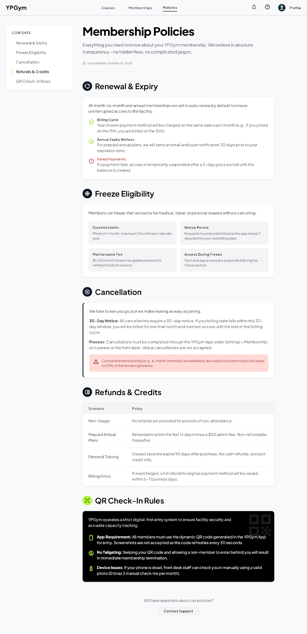
Figure 4. Web/admin screen: Membership Policies

YPGym Home Page
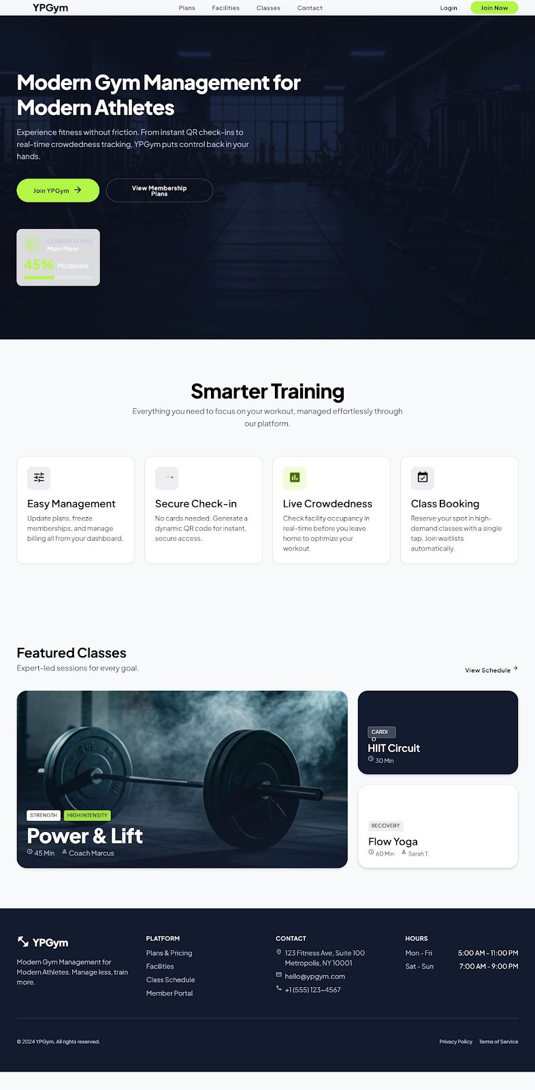
Figure 5. Web/admin screen: YPGym Home Page

Membership Plans
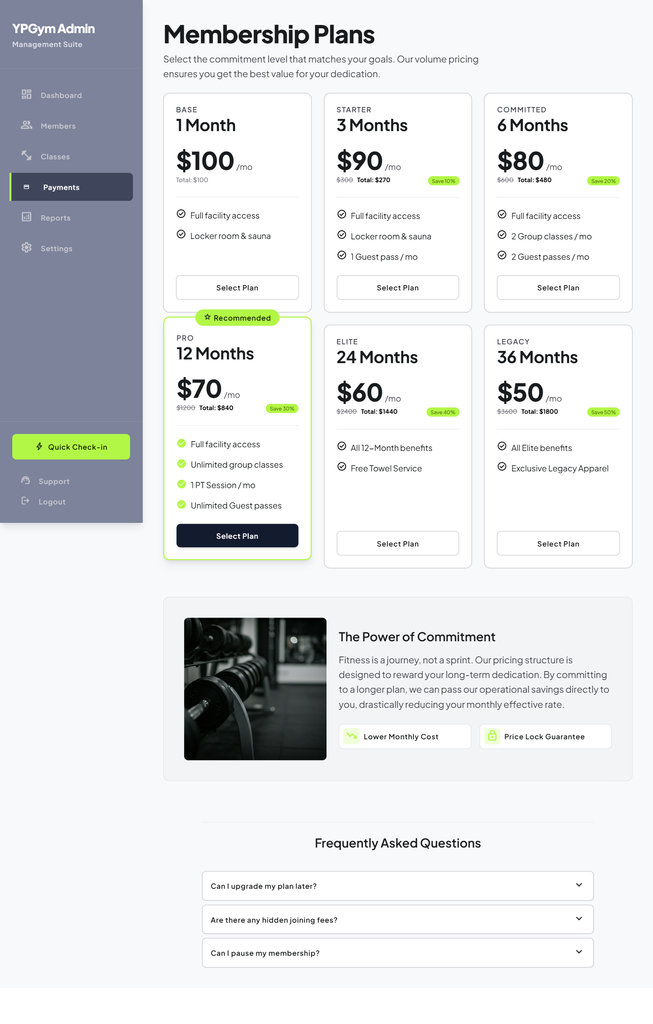
Figure 6. Web/admin screen: Membership Plans

Member Dashboard
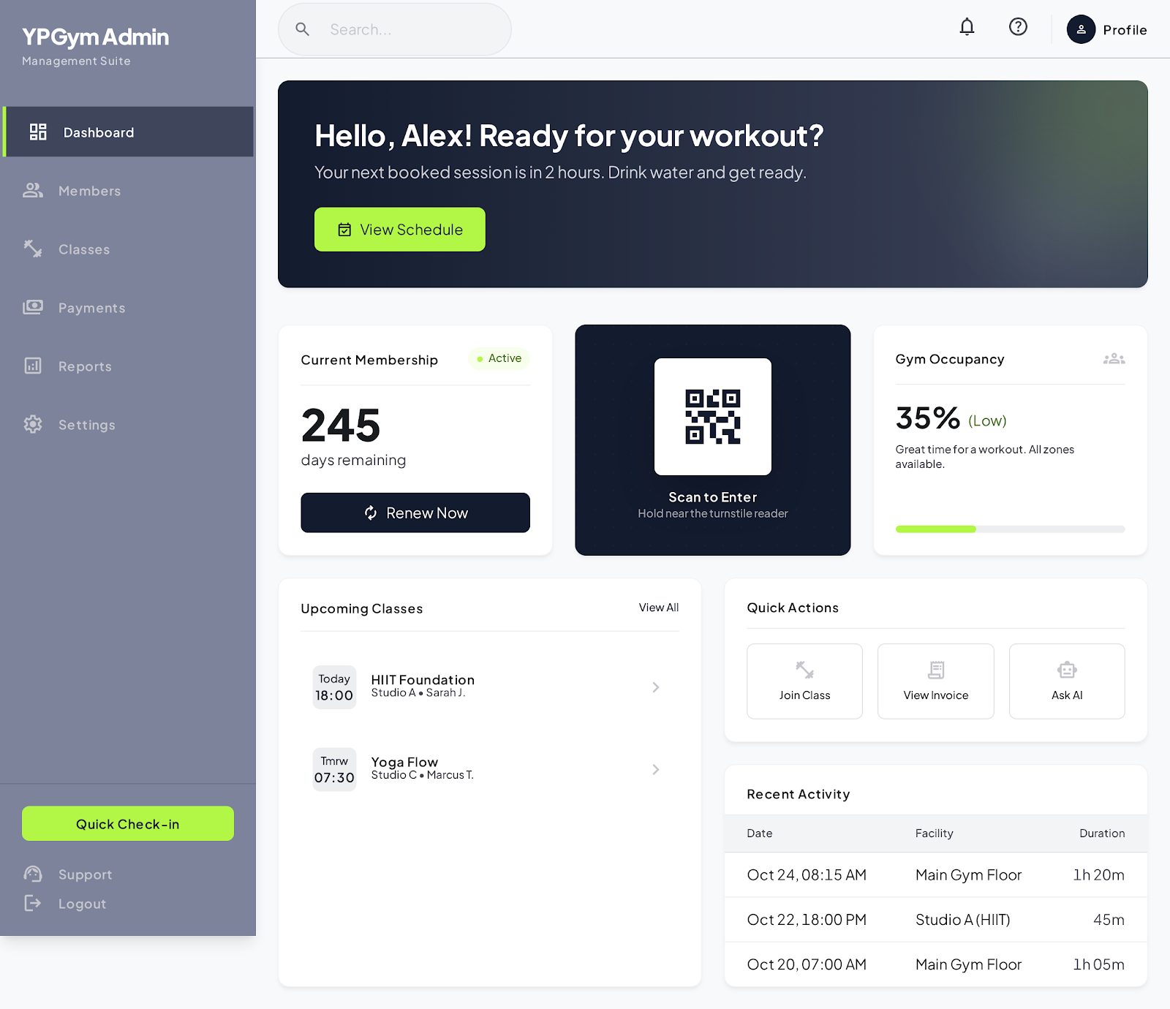
Figure 7. Web/admin screen: Member Dashboard

My QR Code
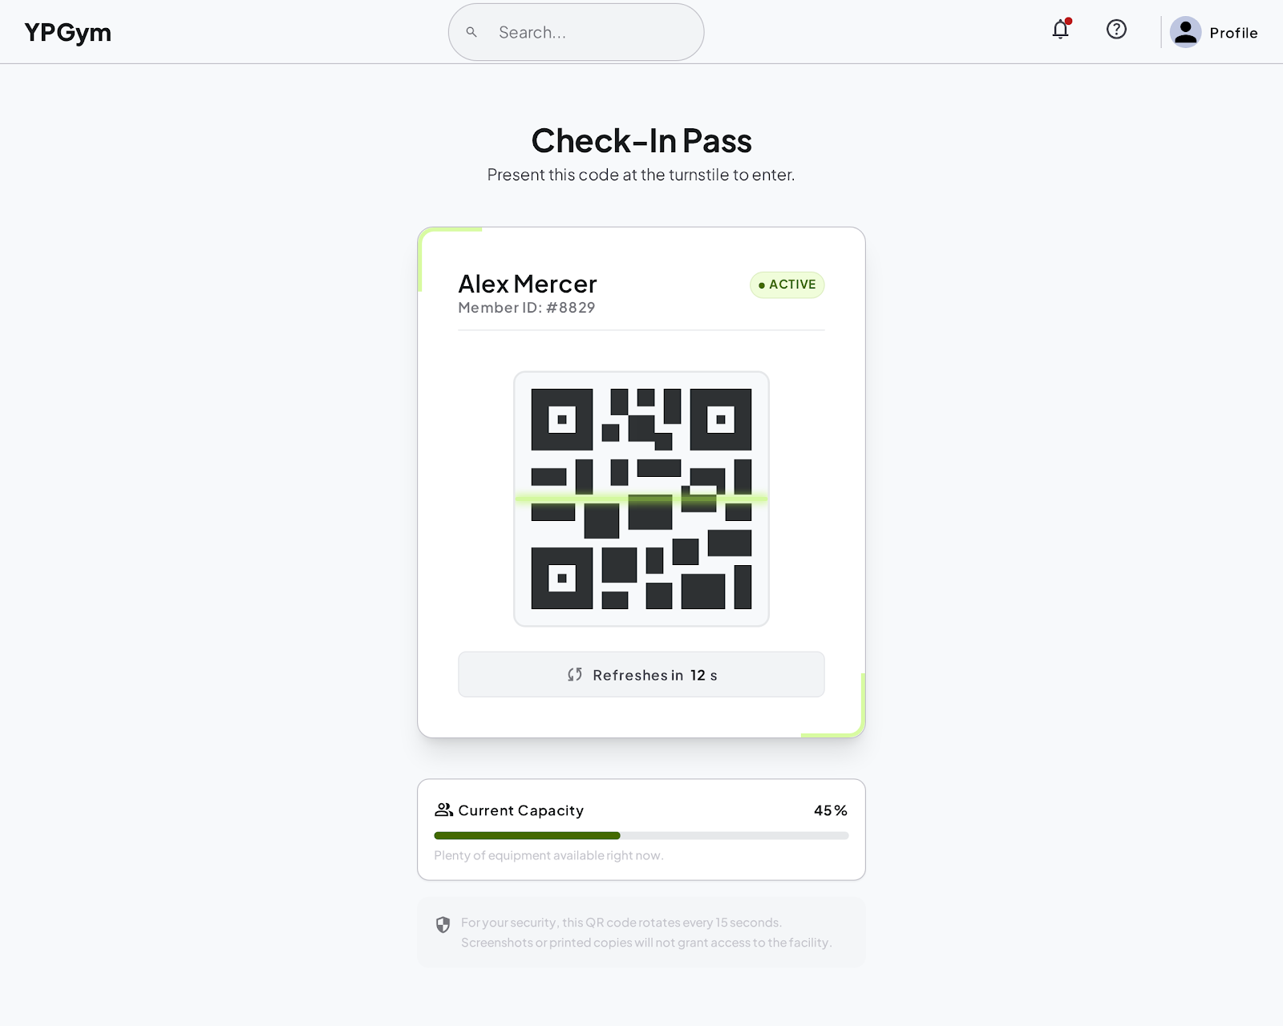
Figure 8. Web/admin screen: My QR Code

Register for YPGym
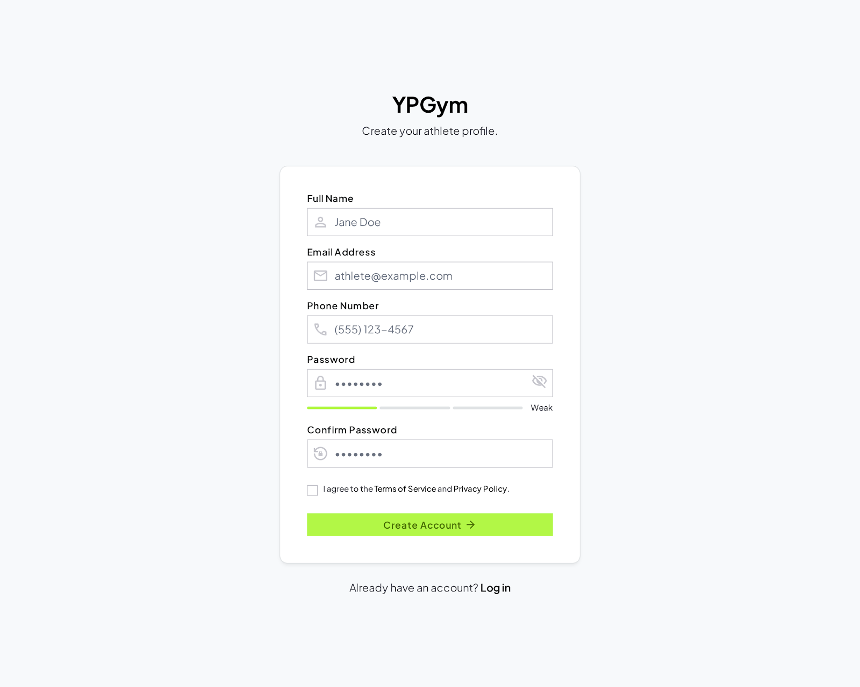
Figure 9. Web/admin screen: Register for YPGym

Login to YPGym
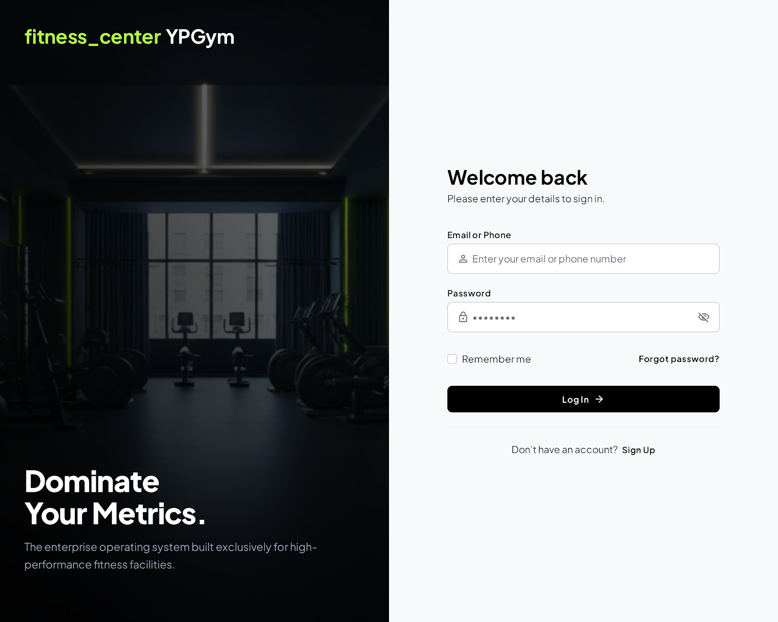
Figure 10. Web/admin screen: Login to YPGym

Forgot Password
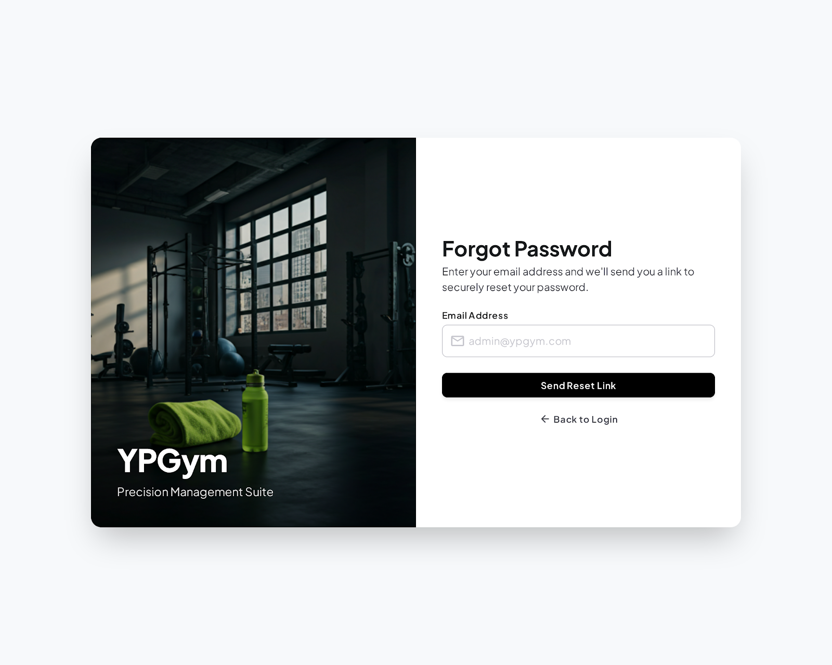
Figure 11. Web/admin screen: Forgot Password

Email Verification Success
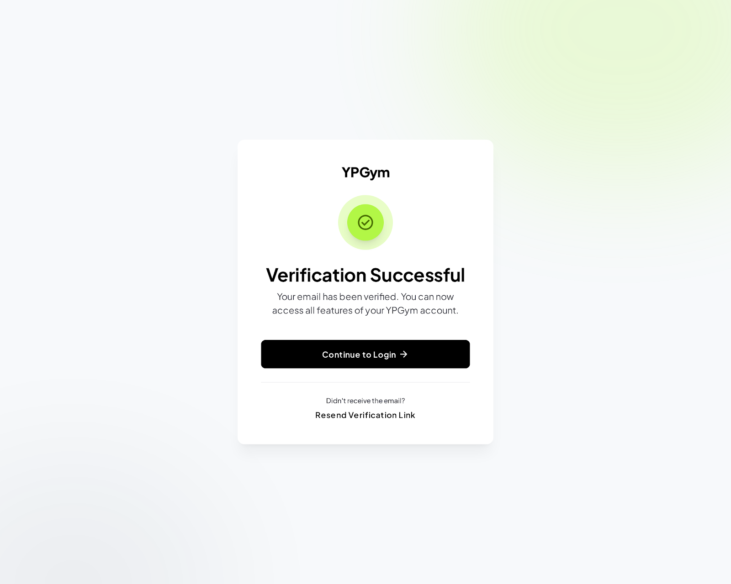
Figure 12. Web/admin screen: Email Verification Success

Member CRM (Updated)
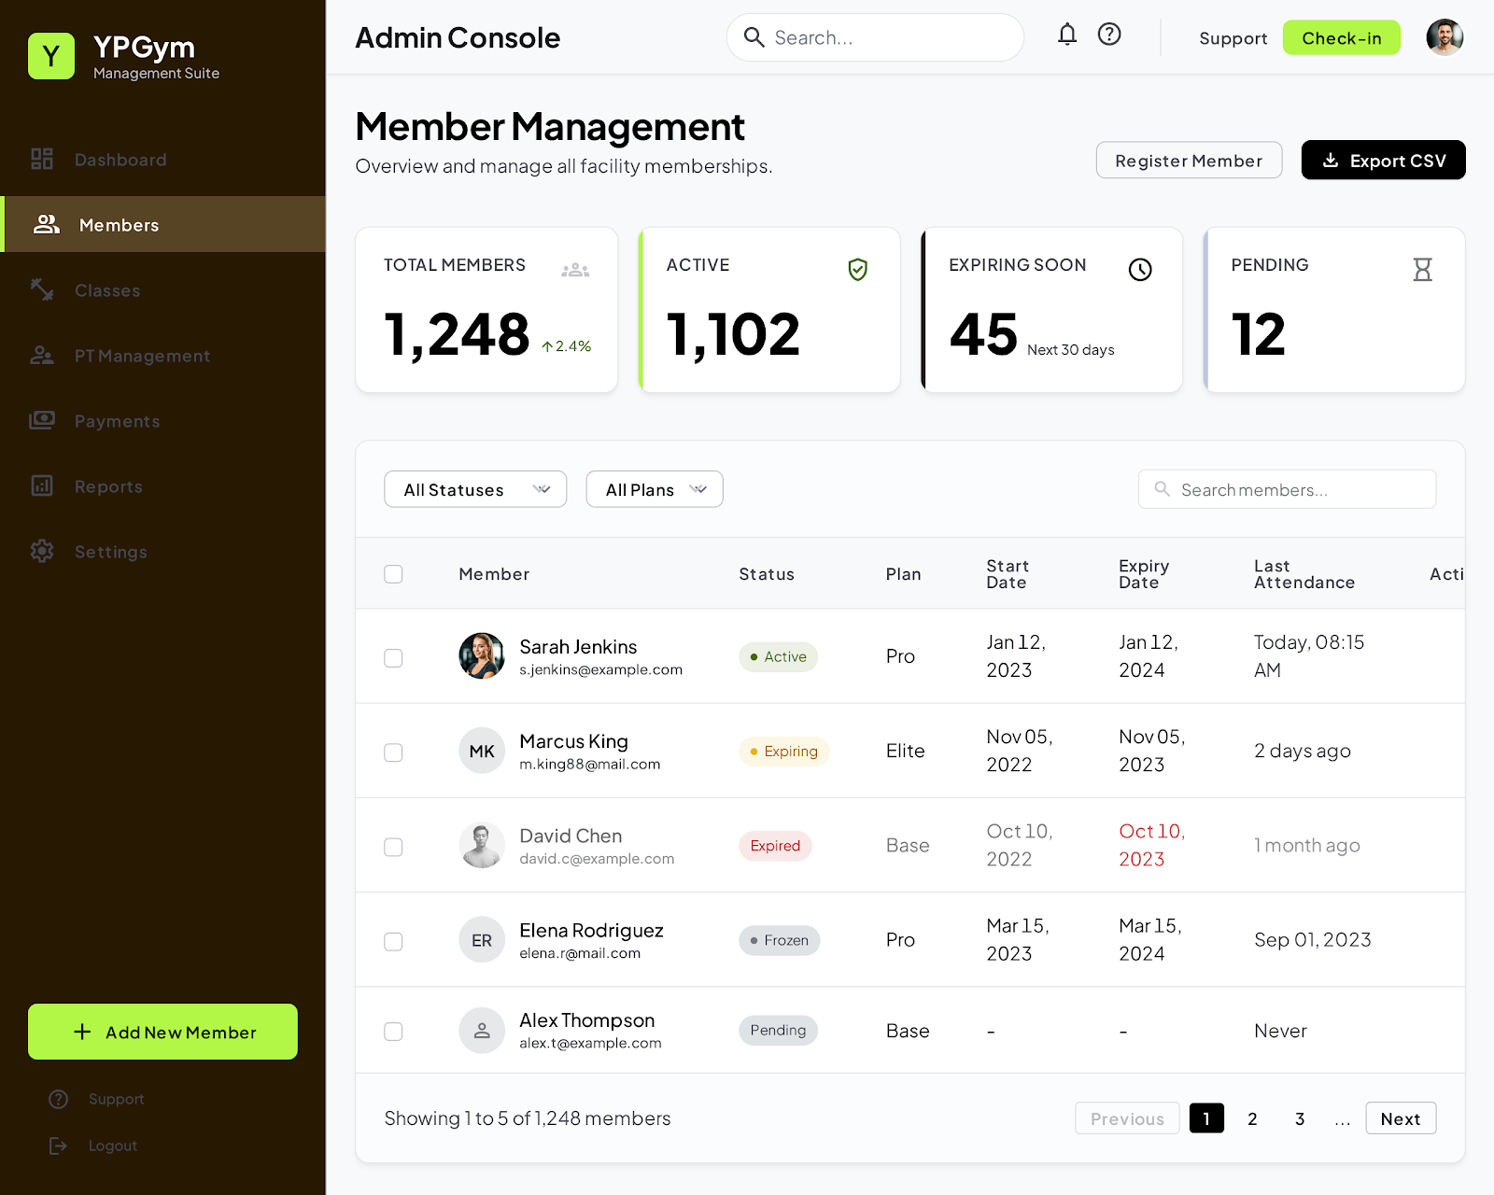
Figure 13. Web/admin screen: Member CRM (Updated)

Admin Member Details (Updated)
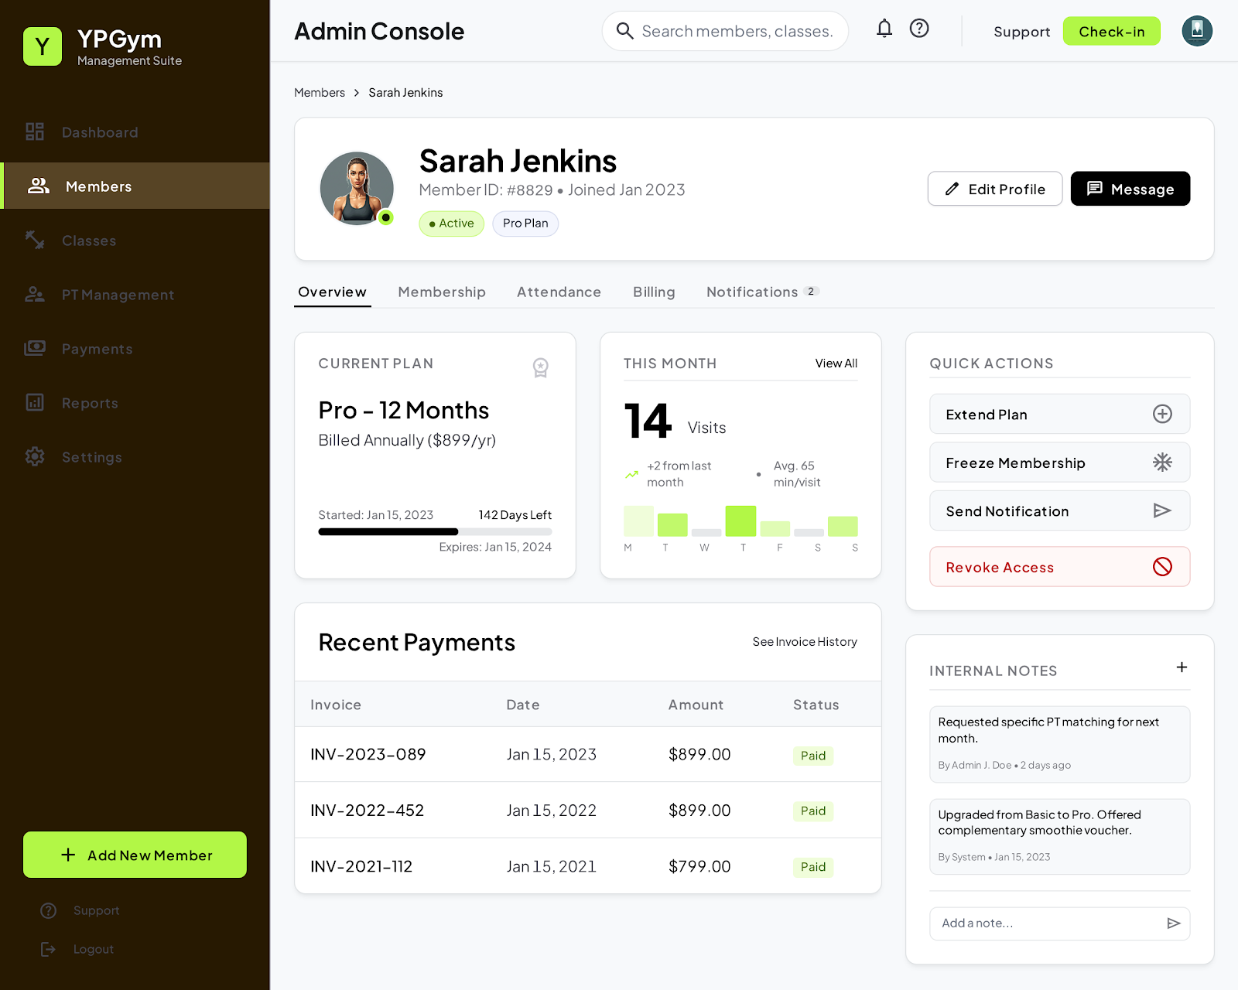
Figure 14. Web/admin screen: Admin Member Details (Updated)

Class & Schedule Management (Updated)
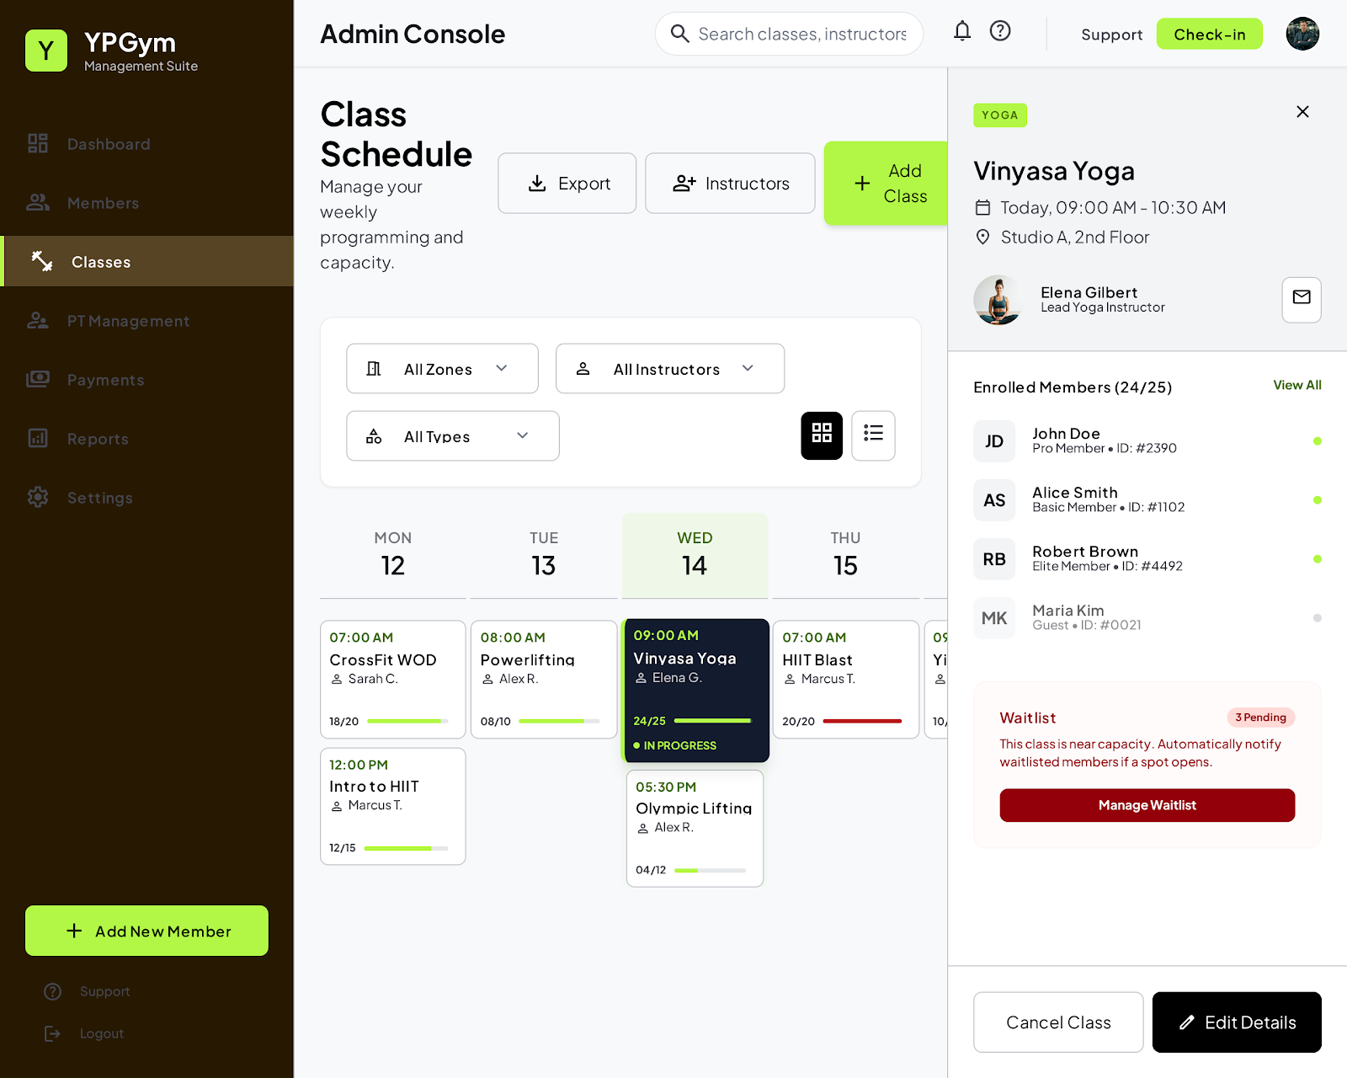
Figure 15. Web/admin screen: Class & Schedule Management (Updated)

Attendance Dashboard
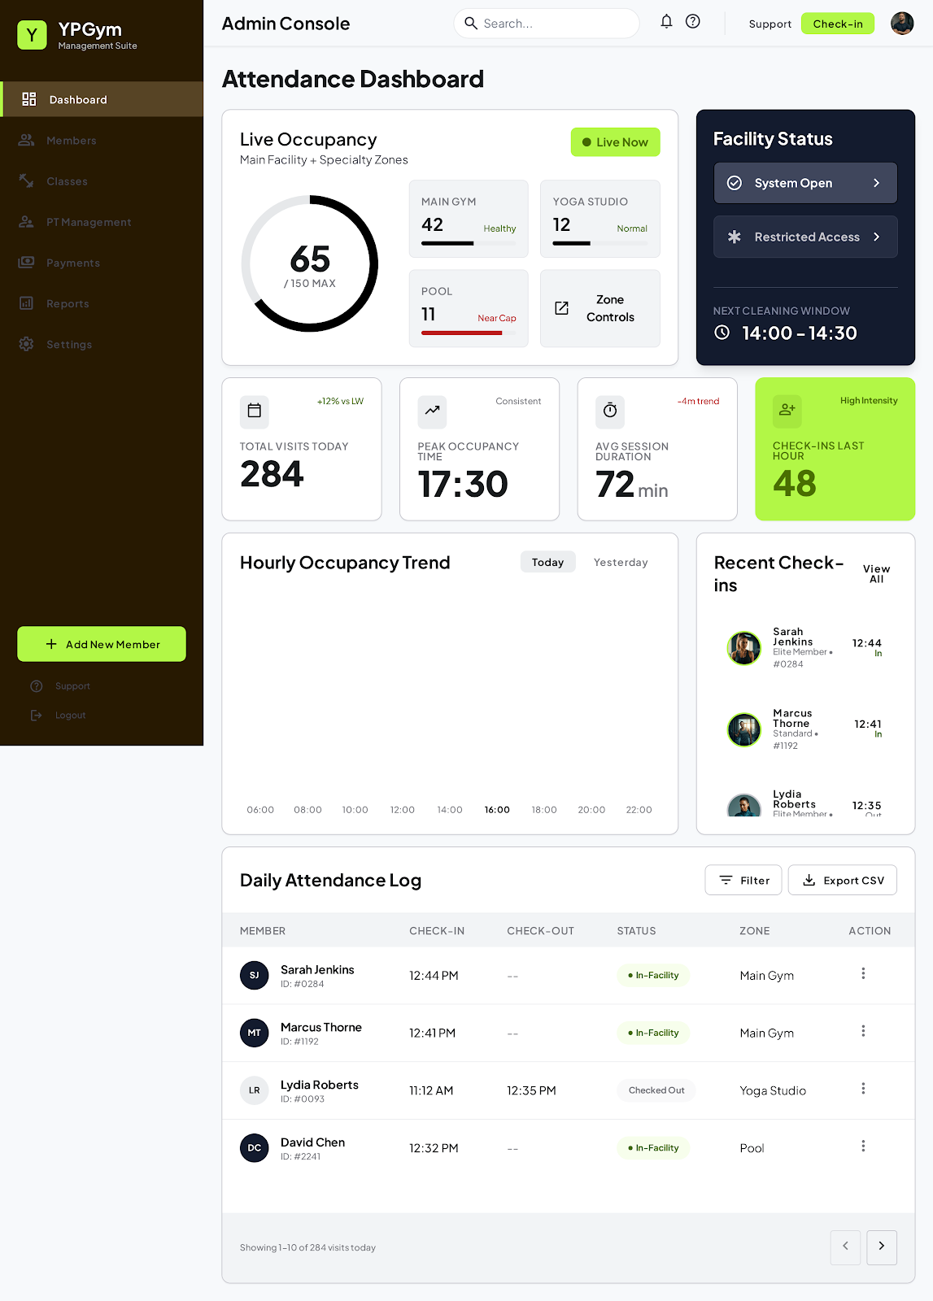
Figure 16. Web/admin screen: Attendance Dashboard

PT Assignment Management
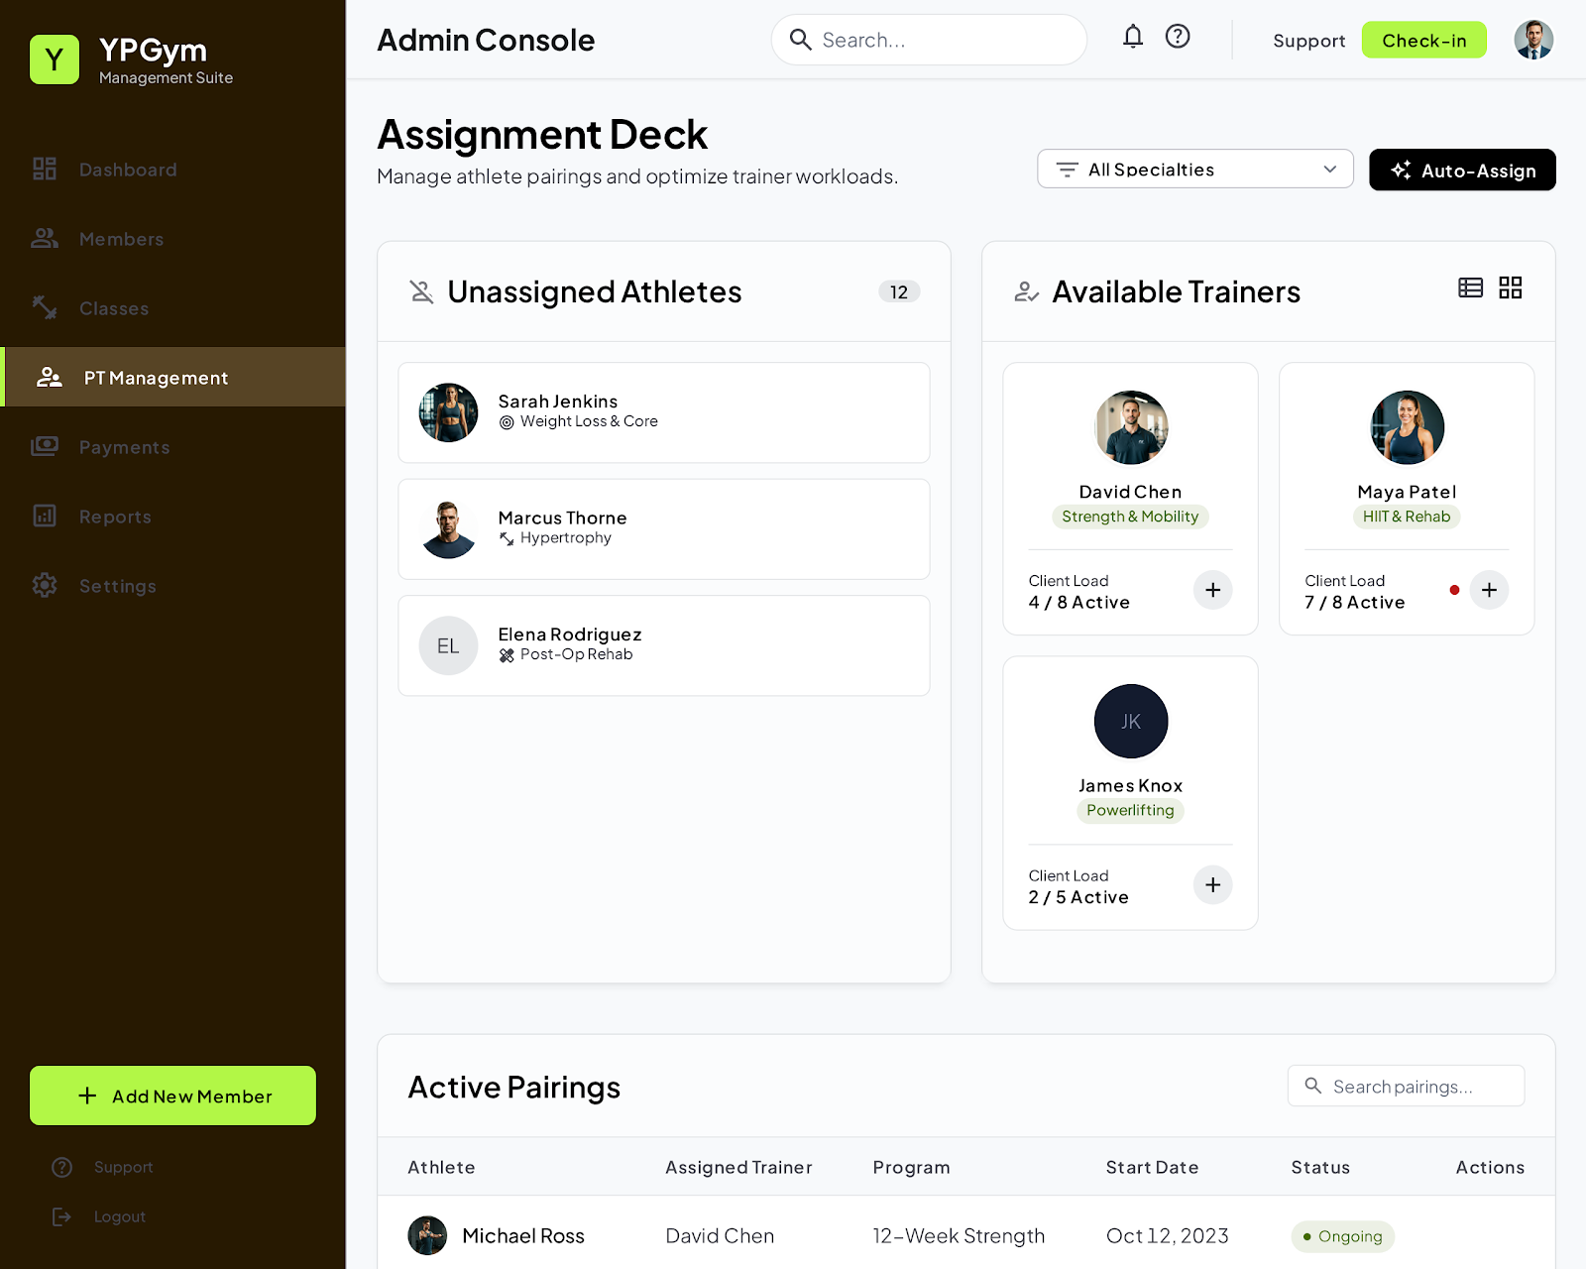
Figure 17. Web/admin screen: PT Assignment Management

Personal Trainer Dashboard
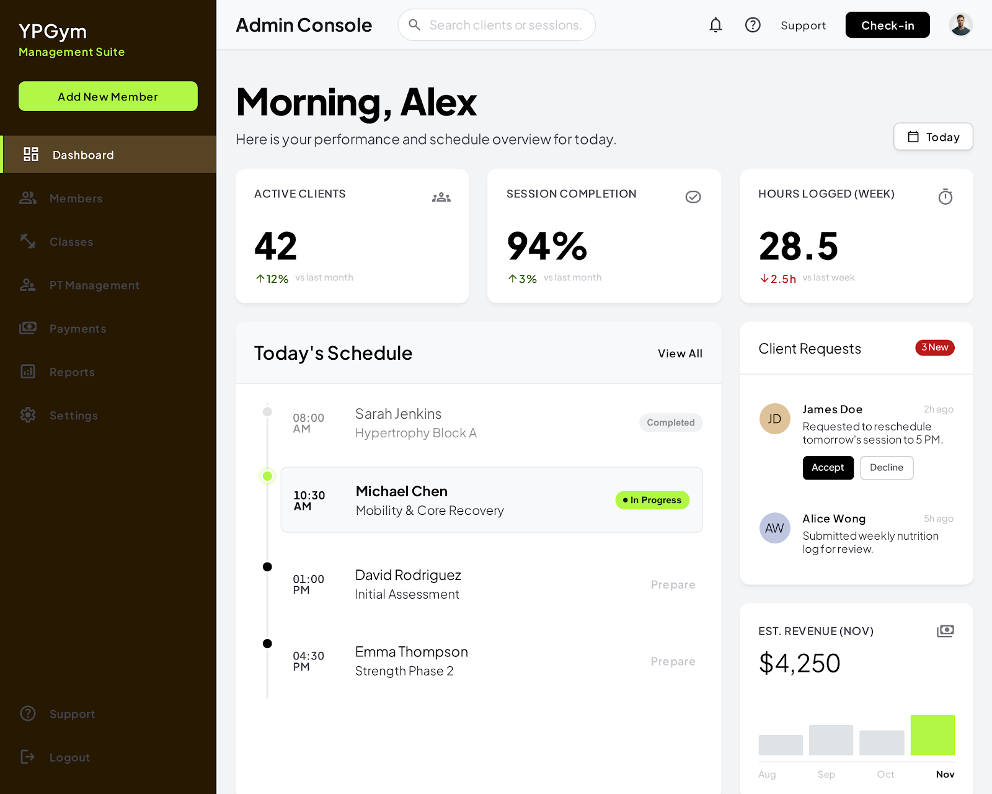
Figure 18. Web/admin screen: Personal Trainer Dashboard

10.2 Mobile Member App Screens
The mobile screens show member-facing flows for dashboard access, renewal, QR check-in, class booking and profile management.
Member Dashboard | Membership Renewal Selection
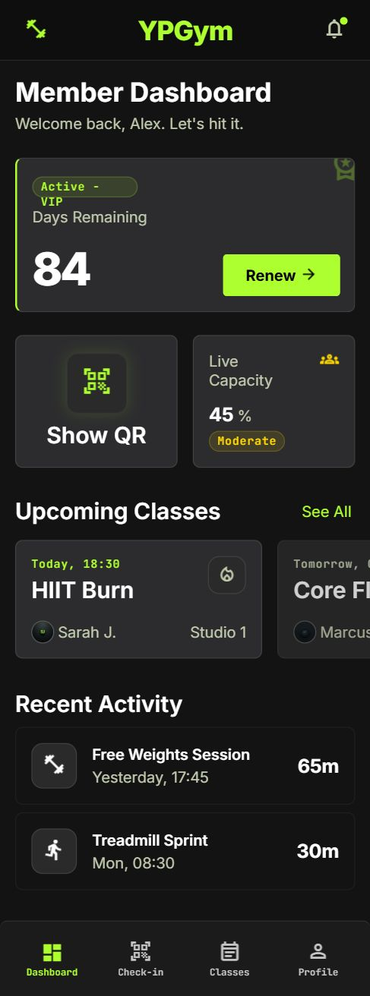 | 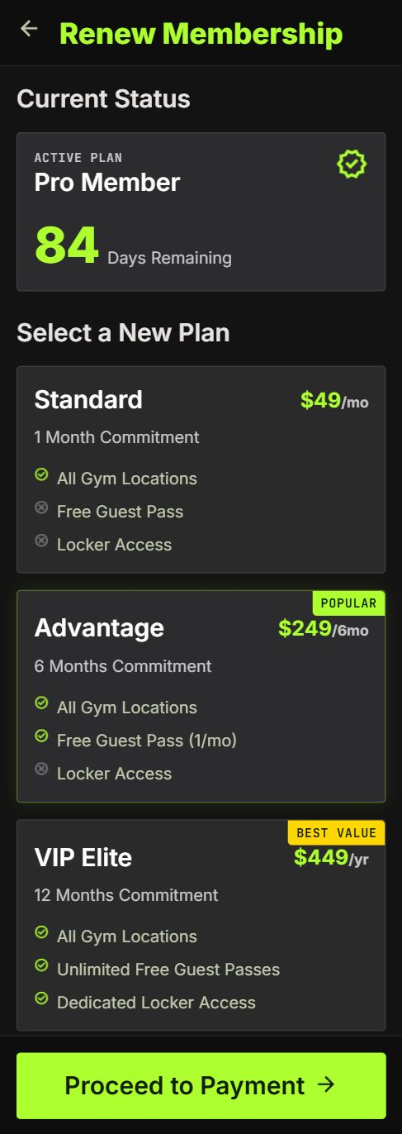
Figure 19. Mobile screen: Member Dashboard | Figure 20. Mobile screen: Membership Renewal Selection

Renewal Success | QR Check-in
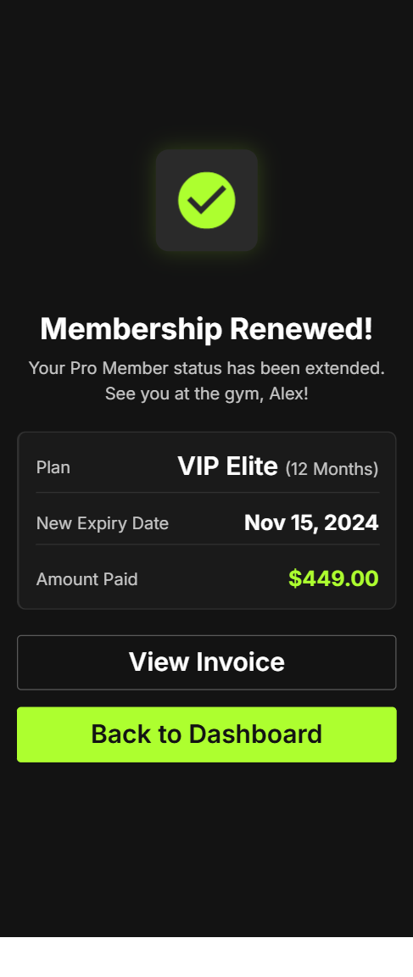 | 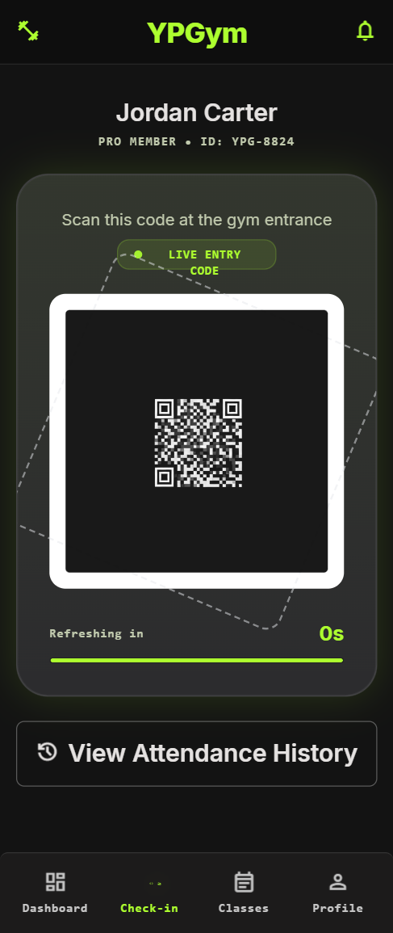
Figure 21. Mobile screen: Renewal Success | Figure 22. Mobile screen: QR Check-in

Class Booking | Member Profile
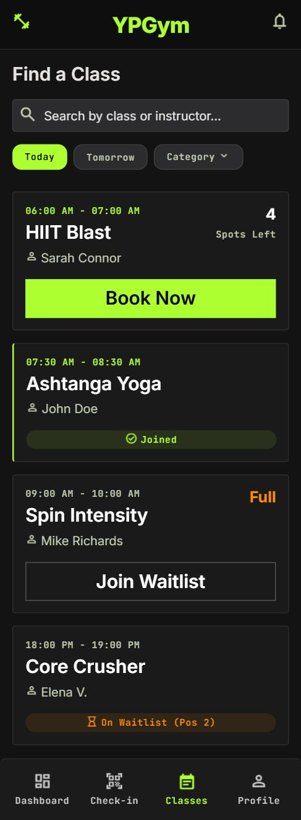 | 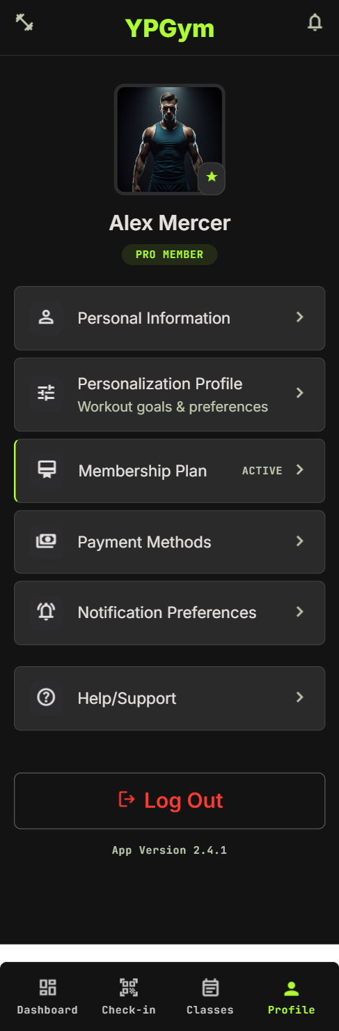
Figure 23. Mobile screen: Class Booking | Figure 24. Mobile screen: Member Profile

11. Suggested Database Tables
Table | Purpose
users | Stores account, authentication and profile details.
email_verifications | Stores email verification tokens and expiry.
password_resets | Stores password reset tokens and expiry.
membership_plans | Stores plan duration, price and discount rules.
user_memberships | Stores member membership lifecycle, start date, expiry date, status and freeze details.
qr_tokens | Stores or validates rotating QR token metadata if server-side storage is used.
attendance_sessions | Stores check-in, check-out, timeout and active attendance session data.
classes | Stores class schedules, capacity and assigned PT.
class_bookings | Stores member class registration and cancellation records.
class_waitlists | Stores waitlisted members and queue order.
personal_trainers | Stores PT profile information.
payments | Stores transaction records.
invoices | Stores invoice records and PDF references.
notifications | Stores in-app notifications and delivery status.
notification_preferences | Stores user notification preferences.
cancellation_requests | Stores cancellation request status and refund/credit/forfeit outcome.
audit_logs | Stores sensitive system and admin actions.
broadcast_announcements | Stores admin announcements.
chatbot_logs | Stores chatbot query metadata where appropriate.
fitness_forms | Stores member-submitted fitness goal form data.

12. High-Level User Flows

12.1 Member Registration and Verification Flow
- User opens the Register page.
- User enters name, email, phone and password.
- System validates required fields and duplicate email/phone.
- System creates account with pending verification status.
- System sends verification email.
- User clicks verification link.
- System activates the account and allows full login access.

12.2 Forgot Password Flow
- User opens Forgot Password page.
- User enters registered email address.
- System sends a time-limited reset link or code.
- User opens reset page and enters new password.
- System validates token and updates password securely.
- User logs in using the new password.

12.3 Membership Purchase Flow
- Verified member signs in.
- Member views available membership plans.
- Member selects a plan and reviews price/discount.
- Member completes payment or mock payment.
- System creates payment record and invoice.
- System activates or extends membership.
- System generates rotating QR access capability.
- Member receives confirmation notification.

12.4 QR Attendance and Crowdedness Flow
- Member opens My QR Code page.
- System displays a rotating time-limited QR token.
- Staff or scanner validates QR code at gym entrance.
- System checks membership status, token expiry and duplicate check-in rules.
- System creates active attendance session.
- Member checks out by exit scan or the system automatically expires the session after the configured timeout.
- System recalculates current occupancy as a percentage of gym capacity.
- Member and admin dashboards show updated crowdedness.

12.5 Class Booking and Waitlist Flow
- Member opens Class Booking page.
- System displays available classes, remaining capacity and PT profile card.
- If capacity is available, member books the class.
- If the class is full, member can join waitlist.
- If a booked member cancels within the cancellation window, the system notifies or auto-enrols the next waitlisted member according to policy.
- Member receives booking or waitlist notification.

12.6 Admin CRM and Cancellation Flow
- Admin logs in to the admin dashboard.
- Admin searches for a member in CRM.
- Admin views membership, attendance, billing and cancellation data.
- Admin reviews cancellation request and verifies member details.
- Admin selects refund, account credit or forfeit outcome according to business rules.
- System updates membership status, records billing effect and writes audit log.
- Member receives cancellation outcome notification.

13. Non-Functional Requirements
Category | Requirement
Security | Passwords must be hashed and sensitive endpoints protected by JWT and role-based access control.
Privacy | Personal data, billing records and fitness form data must be protected and only accessible to authorized roles.
Performance | Common dashboard and crowdedness data should load quickly using indexes and caching.
Scalability | Architecture should support 1000+ registered users with multiple backend workers and PostgreSQL.
Usability | The UI should be mobile-friendly, minimal and easy for both members and admins.
Reliability | Payment, invoice and membership activation should avoid duplicate records through transaction-safe backend logic.
Auditability | Cancellation approvals, revocations and sensitive account actions must be logged.
Maintainability | Code should be modular by feature area and documented through API docs.
Accessibility | Pages should use readable contrast, proper labels and responsive layouts.

14. Development Phases
Phase | Scope
Phase 1: Core Account and Membership | Registration, email verification, login, forgot password, profile settings, membership plans, purchase/renewal, invoices and admin member CRM.
Phase 2: Attendance and Class Operations | Rotating QR code, check-in, check-out/timeout, crowdedness, class booking, waitlist, PT profile cards and class cancellation policy.
Phase 3: Admin, Reporting and Notifications | Expiry reminders, notification preferences, admin broadcast, CSV export, audit logs, billing reports and peak-hours heatmap.
Phase 4: AI and Future Fitness Features | Chatbot with authenticated context injection, guardrails, chatbot logs and member fitness form for future exercise plan generation.

15. Recommended MVP Scope
The MVP should prioritise features that demonstrate a complete end-to-end system and are likely to impress examiners during a demo.
- Registration, email verification, login and forgot password.
- Profile settings and notification preferences.
- Membership purchase, renewal, status tracking and invoice generation.
- Rotating QR attendance with check-in and automatic timeout.
- Capacity-based gym crowdedness display.
- Class booking with waitlist and PT profile card.
- Admin CRM, billing view, CSV export and audit log.
- Membership cancellation workflow with clear refund/credit/forfeit rule.
- Expiry reminders and admin broadcast announcements.
- AI chatbot with backend context injection and guardrail responses.

16. Final Integrated Project Description
YPGym is a full-stack gym management web application designed to digitalize membership registration, account verification, membership purchase and renewal, QR-based attendance tracking, crowdedness monitoring, class booking, billing, notifications, admin CRM operations and controlled AI-assisted support. The system uses React, TypeScript, Tailwind CSS and shadcn/ui on the frontend to provide a sleek mobile-friendly user experience, while FastAPI, PostgreSQL, SQLAlchemy and Redis provide a scalable Python backend suitable for 1000+ registered users.
The application includes a secure account lifecycle with email verification, forgot password and profile self-update functions. Members can purchase membership plans from 1 month to 3 years, receive invoices, use rotating time-limited QR codes for attendance and book classes with waitlist support. Attendance sessions include check-out or automatic timeout logic so gym crowdedness is calculated accurately based on active occupancy as a percentage of gym capacity.
Admins can manage member records, memberships, payments, invoices, class schedules, PT assignments, cancellation requests, revocations, audit logs, CSV exports and broadcast announcements. The AI chatbot is restricted to YPGym-related queries and receives authenticated backend context before responding, allowing it to answer membership, class, PT, crowdedness and navigation questions while redirecting out-of-scope exercise, diet or medical advice to gym staff or personal trainers.

